An Example of Abstract for Awaji Super-Clean Conference ’06

A. Sato,¹ B. Suzuki,¹ C. Tanaka,^{1,2} and D. Takahashi¹

¹Department of Applied Physics, University of Tokyo, Hongo 7-3-1, Bunkyo-ku Tokyo 113-8656
²Institute of Solid State Physics, University of Tokyo, Kashiwanoha 5-1-5, Kashiwa 277-8581

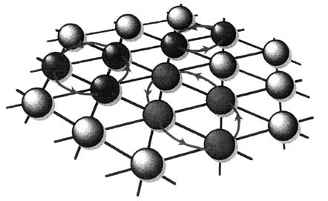
This is an abstract template for the Awaji Conference ’06 on super clean materials. You may use major word processor applications on Windows and MacOS. Please send the word file electronically to super-clean@solis.t.u-tokyo.ac.jp as an e-mail attachment. The deadline for the abstract submission is 31th October 2006. The abstract is a half page of A4 size for each presentation, but may be extended to one page if needed.
FIG.1: Schematic drawing of two-, three-, and four-particle exchanges in a triangular lattice.

The margins of each page are 25 mm for four sides.The recommended font is Times New Roman, Helvetica, Arial, or a similar font. The font size is 14 pt. for the title. Author names are written with the font of Times New Roman or a similar font, and their size is 12 pt. The affiliations of the authors are written with Times New Roman or a similar font. They are of 11 pt in size and are slanted. The authors and the affiliations are related with serial numbers. The font is Times New Roman or a similar font and the size is 11 pt.
The references are cited with a number between parentheses, like [1]. Figures are inserted at suitable positions (Fig.1).
[1] M. Imada et al., J. Phys. Soc. Jpn. 75 (2006) 123456.

